Synthetic Image Generation
Kommineni Deepika, Software Engineer

Keywords: Synthetic Image Generation, Image Generation.
Introduction:
Synthetic Imaging is the creation of two-dimensional optical images by means of mathematical modelling computations of compiled data rather than by the more traditional photographic process of using light waves focused through cameras or other optical instruments
- Synthetic Image generation is the creation of artificially generated images that look as realistic as real images.
- These images can be created by Generation Adversarial Networks(GAN) which use a generator-discriminator architecture to train, generate and rate synthetic images that create a creation-feedback loop that runs multiple times until the generated synthetic image can fool the discriminator enough to be considered a real image. Another way to create synthetic images would be with Variation Auto encoders, and more recently, Vector Quantized Variation Auto encoders (VQ-VAE), which create a discrete latent representation and create more variety of images and is easier to train compared to GANs.
Impact of Synthetic Image Generation:
- Synthetic Image Generation can have varying impacts depending on how it’s used. It can be utilized in several machine learning business problems as well as help solve the scarcity of real data
Pros of Synthetic Image Generation:
- Synthetic Image generation can solve the business problem of scarcity or unavailability of image data by creating synthetic image data.
- Synthetic images can be utilized to train ML models where the existing real image data does not have much variety. Synthetic images can be generated to add more variation to the existing image dataset before training the model.
- Text to image generation can be sued for search engines to create copyright-free images on the go as well as create synthetic images when there are limited search results.
Cons of Synthetic Image Generation:
- Synthetic Image Generation can be used to create fake doctored images that can deceive the public.
- Synthetic Images, if not trained and generated with good accuracy and realism, can reduce the quality of the existing image dataset instead of improving it.
How Synthetic Image Generator Helps:
- It uses two neural networks one that creates an image and another one that judges, based on real-life examples of the target image, how close the image is to the real thing.
- After scoring the image for accuracy, it sends that info back to the original AI system.
Image Generation:
- The image generation stage in a computer graphics visual display device is the final section where the magic of beautiful pictures is created.
- It is where the user has the most interaction with the images and their generation.
- There are two types of image generation:
- The content creation work and the consumption of the content.
- In both cases, there is an unrelenting demand and need for high quality, fast response, and image generation.
Image Generation Options:
- Image size alteration:
Image editors can resize images in a process often called image scaling, making them larger, or smaller. High image resolution cameras can produce large images which are often reduced in size for Internet use. Image editor programs use a mathematical process called resampling to calculate new pixel values whose spacing is larger or smaller than the original pixel values.

Cropping an image:
Digital editors are used to crop images. Cropping creates a new image by selecting a desired rectangular portion from the image being cropped. The unwanted part of the image is discarded. Image cropping does not reduce the resolution of the area cropped. Best results are obtained when the original image has a high resolution

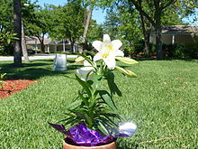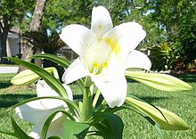
Uncropped image from camera Lily cropped from larger image

Image orientation:
Image editors are capable of altering an image to be rotated in any direction and to any degree. Mirror images can be created and images can be horizontally flipped or vertically flopped. A small rotation of several degrees is often enough to level the horizon, correct verticality (of a building, for example), or both. Rotated images usually require cropping afterwards, in order to remove the resulting gaps at the image edges.
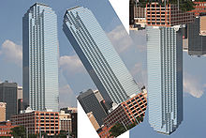

Change color depth
It is possible, using the software, to change the colour depth of images. In addition, grayscale images of 8 bits or less can be created, usually via conversion and down-sampling from a full-colour image. Grayscale conversion is useful for reducing the file size dramatically when the original photographic print was monochrome, but a colour tint has been introduced due to aging effects.
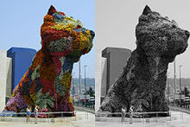

Noise reduction:

Image editors may feature a number of algorithms which can add or remove noise in an image. Some JPEG artifacts can be removed; dust and scratches can be removed and an image can be de-speckled. Excessive noise reduction leads to a loss of detail, and its application is hence subject to a trade-off between the undesirability of the noise itself and that of the reduction artifacts.

Enhancing images:
In computer graphics, the enhancement of an image is the process of improving the quality of a digitally stored image by manipulating the image with software. It is quite easy, Advanced photo enhancement software also supports many filters for altering images in various ways.^{[5]} Programs specialized for image enhancement are sometimes called image editors.

Removal of unwanted elements:
Most image editors can be used to remove unwanted branches, etc., using a "clone" tool. Removing these distracting elements draws focus to the subject, improving overall composition.
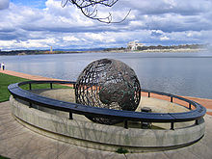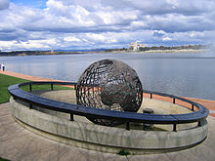
The branch in the original image The eye is drawn to the center of the globe

Enhancing images:
In computer graphics, the enhancement of an image is the process of improving the quality of a digitally stored image by manipulating the image with software. It is quite easy, for example, to make an image lighter or darker, or to increase or decrease contrast. Advanced photo enhancement software also supports many filters for altering images in various ways.^{[5]} Programs specialized for image enhancement are sometimes called image editors.

What is data augmentation:
- Data augmentation uses simple strategic techniques like flipping, resizing, rotating etc. on image objects with respect to the background to produce diversity in the available images.
- It is most commonly used to train and improve neural networks by using artificial data produced from existing data.

DATA AUGMENTATION TECHNIQUES USED:
Below, are the basic operations performed on images to produce variations.
- FLIP:
We can flip the images with respect to the axis randomly or in the x and y plane.
- ROTATE:
We can rotate the images by setting the min-max angles and get desired augmented results.

- RANDOM SIZE:
We can resize the images by setting the min-max width of the image according to our desired results.

The Process Of Synthetic Image generation:
Synthetic Image generation is the process of artificially generating images that contain some particular desired content. It is analogous to the inverse of the classification problem, generating an image that contains the visual contents that are associated with a specific label.
- The process of generating any kind of data synthetically or artificially via programming is called Synthetic Data Generation.
- The data that can be used in these techniques can be images, text, audio, video, and so on. In this article, we will focus on Synthetic Image data Generation.
- The advantage of using this technique is to have heterogeneity in the images for better learning of the model.
- Alright! but how does this exactly work, Will the accuracy improve by using this technique
- Well, the obvious answer is yes. There are many resources and research that claims to give better results. So, it is evident that using the Synthetic Data Generation technique can significantly increase your model performance and accuracy.

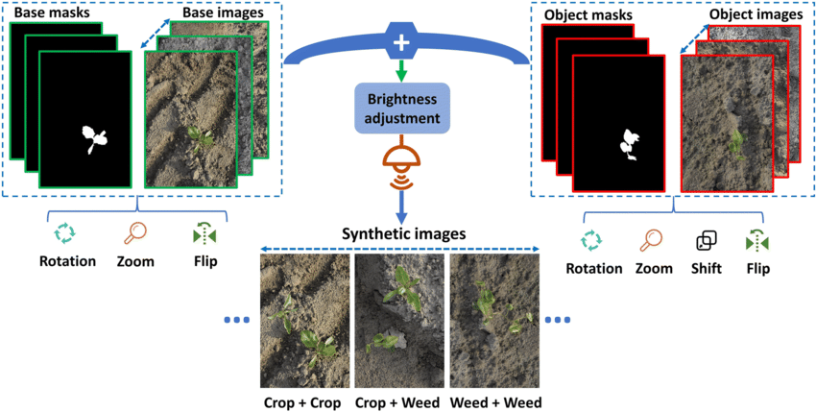

CONCLUSION:

In this article, we have seen a simple technique with which we can create multiple data with the existing one. For simplicity, I just extracted the foreground and pasted it onto a different background. You can go beyond this and can create your own images with different parameters (colour, rotation, and more).
References:
- https://www.analyticsvidhya.com/blog/2022/01/an-introduction-to-synthetic-image-generation-from-text-data/
- https://en.wikipedia.org/wiki/Image_editing#Selecting_and_merging_of_images
- https://link.springer.com/referenceworkentry/10.1007/978-3-642-35947-7_171-1?noAccess=true

About Author:
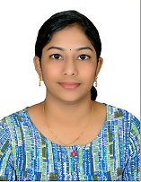

Kommineni Deepika holds Master’s Degree in Computer Applications from GIET College Rajahmundry. She is currently working as Software Engineer with ERS Research team and involved in Data Engineering products development.

